**Introduction**

1.1 Overview

**Starting a new company can be an exciting and rewarding experience, but it also requires careful planning and analysis to ensure that the business is viable and successful. There are several key areas that you should focus on when conducting a startup company analysis. Conducting a thorough analysis of these areas can help you identify potential challenges and opportunities, and develop strategies to address them. It is also important to regularly review and update your analysis as the business progresses, in order to adapt to changing market conditions.**

**Tableau allows users to create interactive dashboards and visualizations,which can be used to explore different aspects of the different company data identify trends and compare the performance of different companies.The visualization can be customized with various chart types,colors,and filters,making it easy to present complex data in an interactive and easy-to-understand format.**

1.2 Purpose

**The purpose of the analysis of starting a new company creating a product or service that people desire.Developing a plan to make money by selling this item.Pushing yourself and your team to manufacture the product and sell it before you run out of your initial investment.To solve a problem and do it better than anyone else.**

**By using tableau,the analysis can provide a detailed and customizable view of the financial data,allowing users to explore different aspects of the data and identify patterns,trends and outliers.This can help stakcholders to identify areas of strength and weakness,understand the risks and opportunities associated with the companies,and make informed decisions about investments,regulatory policies,and other strategic decisions.The analysis of financial performance of leading companies with Tableau can also provide insights into the broader trends and challenges facing the industry.**

**The purpose of a business is to offer value (through products and/or services) to customers, who pay for the value with cash or equivalents. Minimally, the money received should fund the costs of operating the business as well as provide for the life needs of the proprietor.**

**Any money in excess of these needs of funding and salary—”margin” or “profit”—may be used to reinvest in the business; to be invested for future needs and security; and/or to be used for philanthropy and the environment.**

**There are direct actions required in this process: the acquisition, perpetuation, and expansion of customer business. These actions may also include R&D (creating new value); marketing (creating need); and finance (pursuing receivable to create better cash flow).**

2.Problem definition and Design thinking

2.1 Empathy map

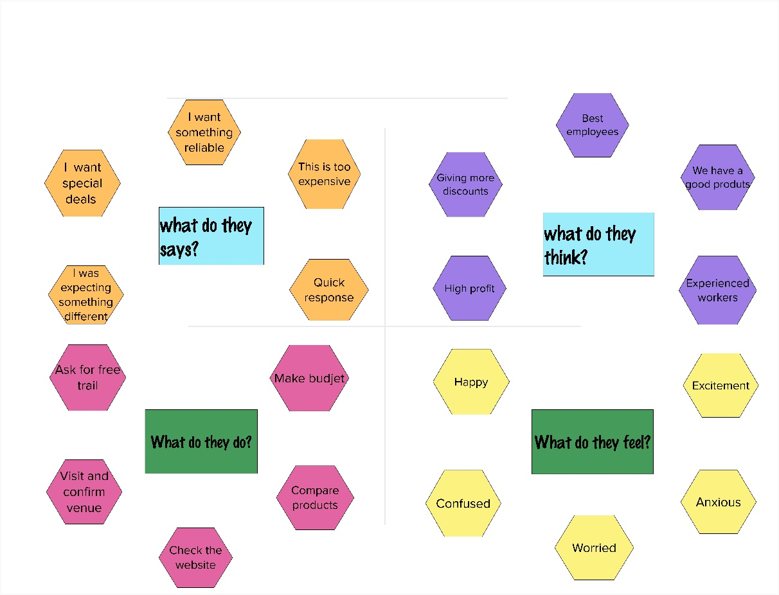

2.2 ideation and brainstorming map

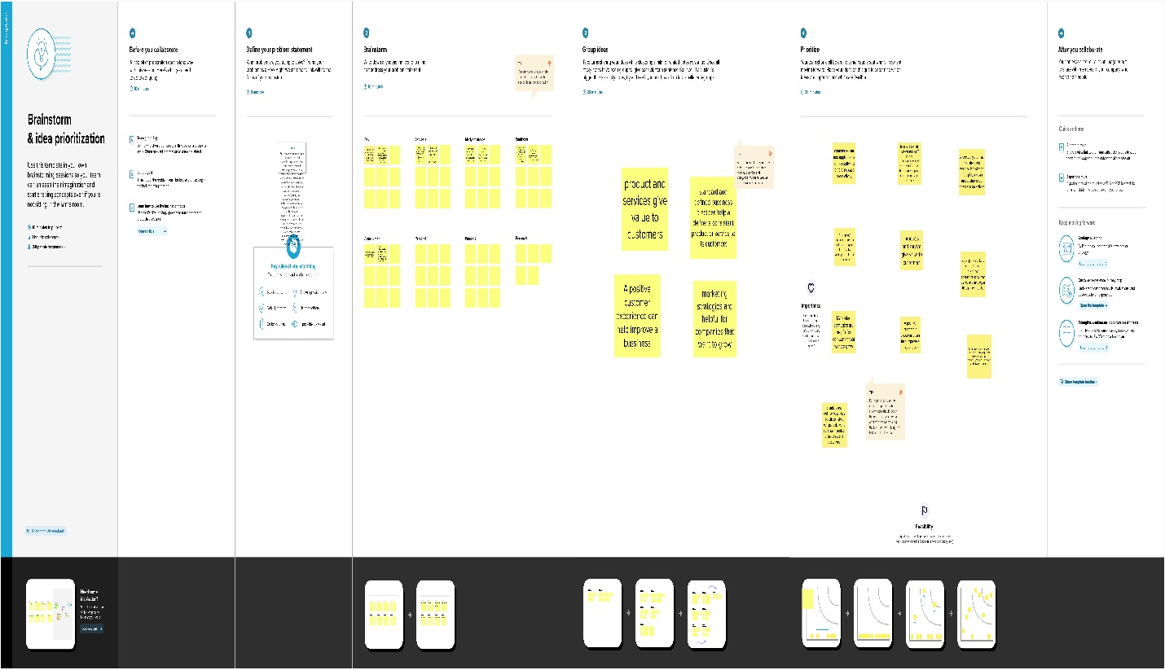

3.Results

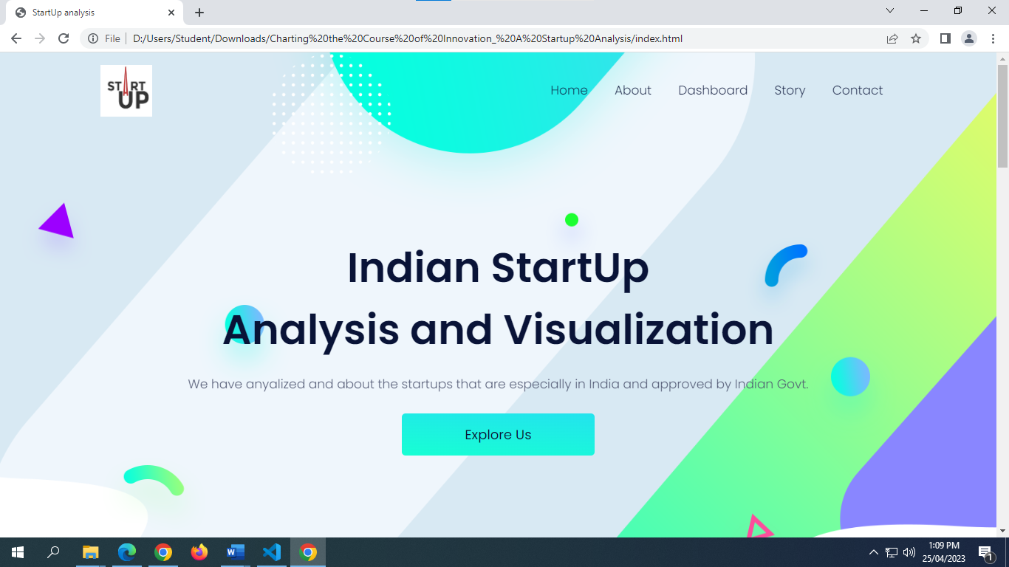

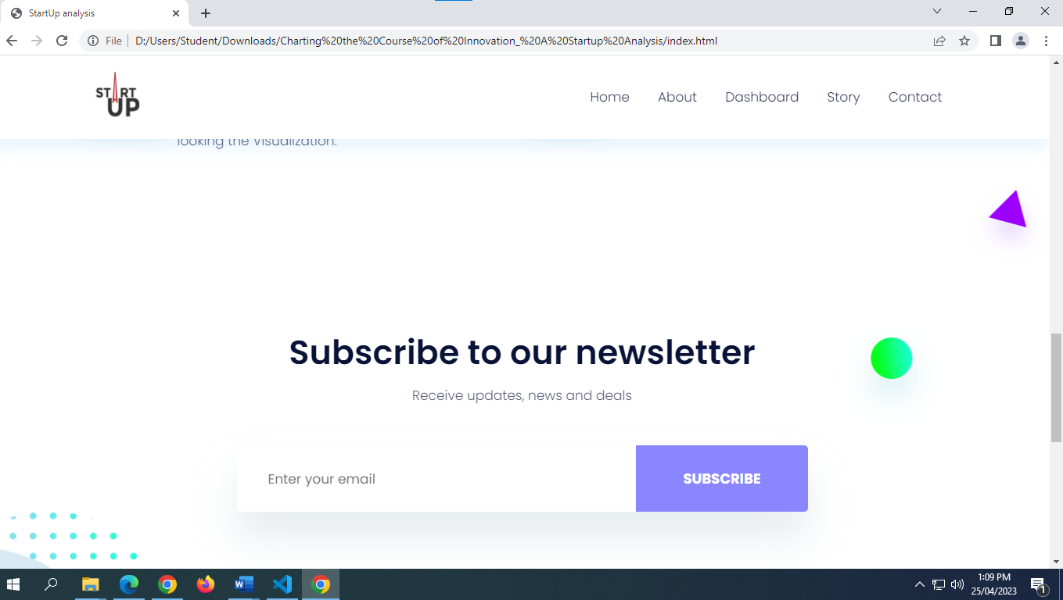

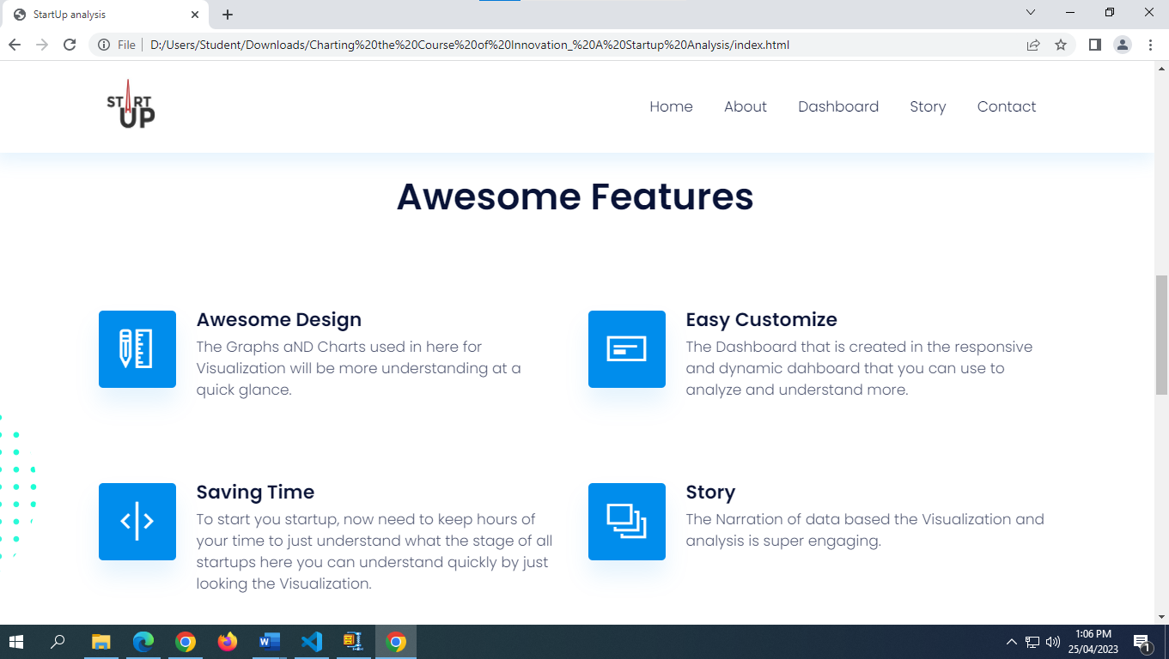

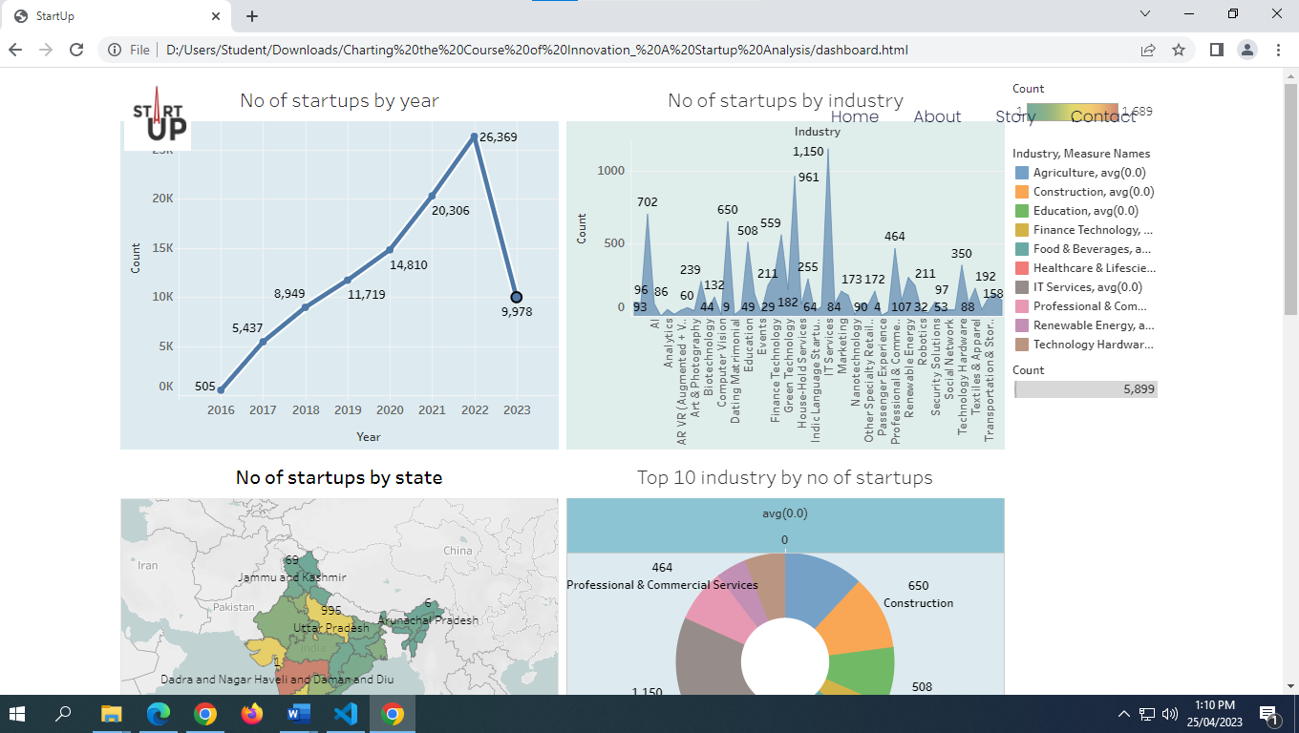

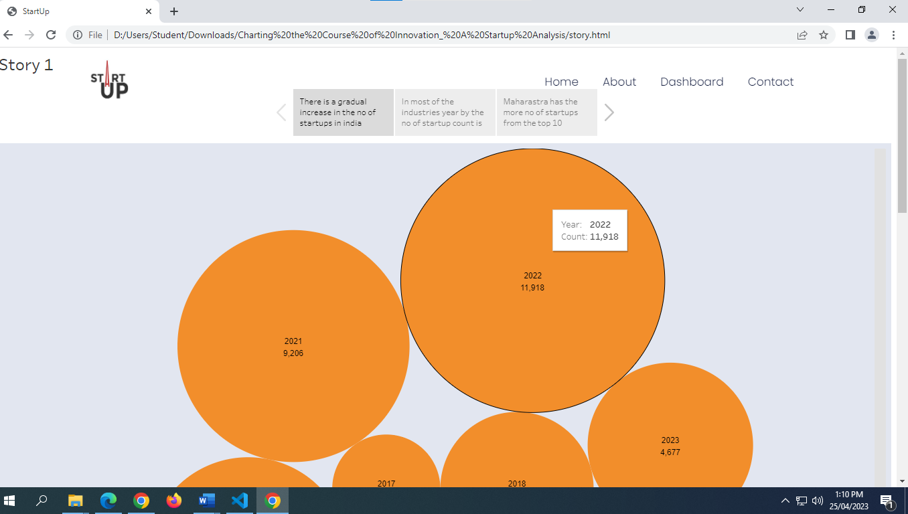

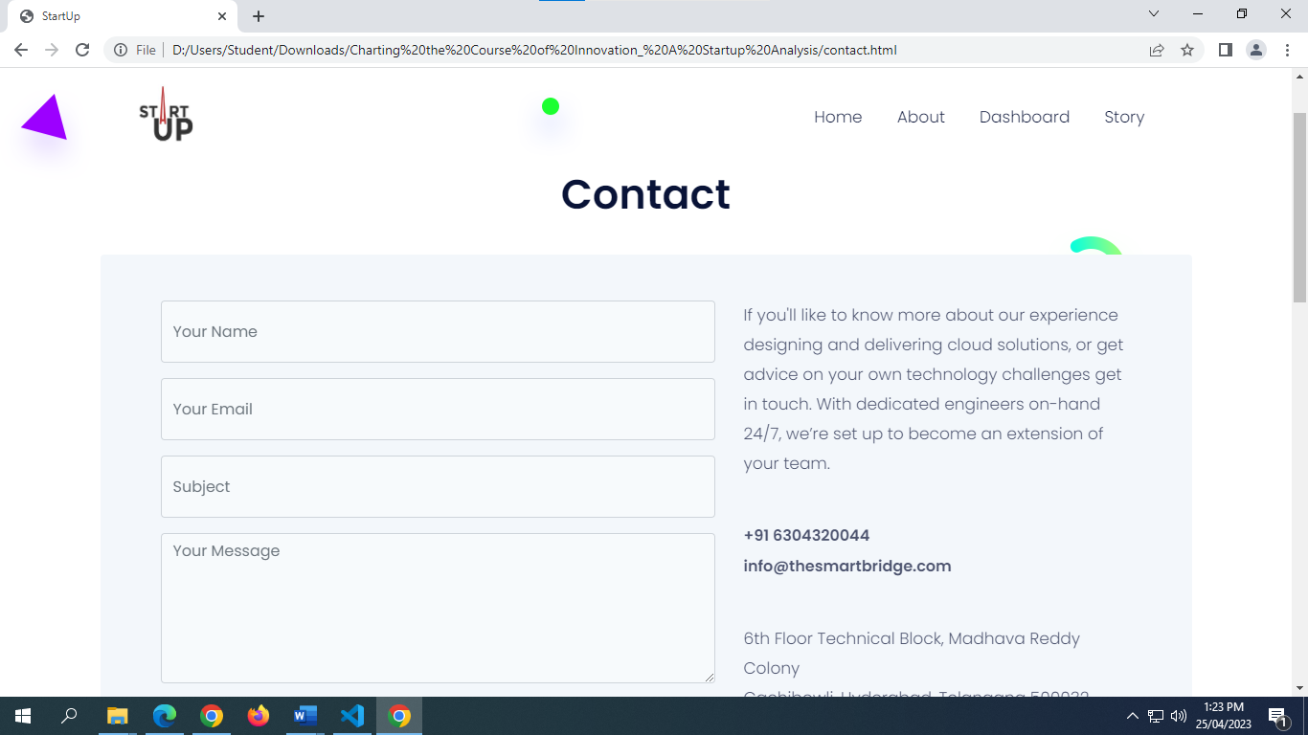

4.Advantages & disadvantages

* 1. Advantages

**Independence: As a business owner, you’re your own boss. You can’t get fired. More importantly, you have the freedom to make the decisions that are crucial to your own business success.**

**Lifestyle: Owning a small business gives you certain lifestyle advantages. Because you’re in charge, you decide when and where you want to work. If you want to spend more time on nonwork activities or with your family, you don’t have to ask for the time off. If it’s important that you be with your family all day, you might decide to run your business from your home. Given today’s technology, it’s relatively easy to do. Moreover, it eliminates commuting time.**

**Financial rewards: In spite of high financial risk, running your own business gives you a chance to make more money than if you were employed by someone else. You benefit from your own hard work.**

**Learning opportunities: As a business owner, you’ll be involved in all aspects of your business. This situation creates numerous opportunities to gain a thorough understanding of the various business functions.**

**Creative freedom and personal satisfaction: As a business owner, you’ll be able to work in a field that you really enjoy. You’ll be able to put your skills and knowledge to use, and you’ll gain personal satisfaction from implementing your ideas, working directly with customers, and watching your business succeed.**

4.2 disadvantages

**Financial risk: The financial resources needed to start and grow a business can be extensive. You may need to commit most of your savings or even go into debt to get started. If things don’t go well, you may face substantial financial loss. In addition, there’s no guaranteed income. There might be times, especially in the first few years, when the business isn’t generating enough cash for you to live on.**

**Stress: As a business owner, you are the business. There’s a bewildering array of things to worry about—competition, employees, bills, equipment breakdowns, customer problems. As the owner, you’re also responsible for the well-being of your employees.**

**Time commitment: People often start businesses so that they’ll have more time to spend with their families. Unfortunately, running a business is extremely time-consuming. In theory, you have the freedom to take time off, but in reality, you may not be able to get away.**

**Undesirable duties: When you start up, you’ll undoubtedly be responsible for either doing or overseeing just about everything that needs to be done. You can get bogged down in detail work that you don’t enjoy. As a business owner, you’ll probably have to perform some unpleasant tasks, like firing people.**

**5. applications**

**Investment Management: Financial analysis of world companies can help investment managers to identify potential investment opportunities and make informed decisions about their investments in the company sector.**

**Regulatory Compliance: Financial analysis can help companies to comply with regulatory requirements and maintain regulatory standards.**

**Risk Management: Financial analysis can help companies to identify potential risks and develop strategies to manage them effectively.**

**Strategic Planning: Financial analysis can provide valuable insights into the financial health, profitability, and overall performance of companies,which can inform strategic decisions and help companies to plan for the future.**

**Competitive Analysis: Financial analysis can be used to compare the financial performance of different companies, identify industry best practices,and set benchmarks for performance.**

**Investor Relations: Financial analysis can be used to provide investors with insights into the financial health and performance of banks, helping to build trust and confidence in the industry.**

**6.conclusion**

**The work involved a comprehensive analysis of financial performance of**

**leading companies, using Tableau as a data visualization tool. The purpose of**

**the analysis was to provide stakeholders with insights into the financial health,**

**profitability, and overall performance of the banks and to enable them to make**

**informed decisions about investments, regulatory policies, and other strategic**

**decisions.**

**The analysis involved collecting and importing financial data from**

**various sources into Tableau, cleaning and transforming the data, and creating**

**interactive dashboards and visualizations to explore different aspects of the**

**data. The analysis also used advanced features of Tableau, such as forecasting**

**and machine learning, to identify patterns and trends in the financial data and**

**predict future performance of the companies.**

**The findings of the analysis provided valuable insights into the financial**

**performance of different companies, identifying areas of strength and weakness**

**potential risks, and opportunities. The analysis also allowed for benchmarking**

**and comparison of the financial performance of different companies, which can**

**in form industry best practices and set benchmarks for performance.**

7. future scope

**Robotics: There is an enormous level of new interactions that are in store between people and machines.**

**Transportation tech: There are a number of self-driving startups already. We will come to a point where the cars will become like PCs - where the hardware becomes less important/commoditized and there will be a host of software players who will help run the system & add features.**

**Energy tech: As solar becomes cheaper than conventional fuels, it will take over the grids everywhere. That will require smart load balancing, better battery technologies.**

**Space tech: With nanosatellites able to be built by anyone and low orbit rockets launched by private companies, we will come to a point where there will be a number of tiny SpaceX all building equipments for the new space race. Over 100 countries will wait for their services to get them to space.**

**Health tech: There is already some tech in healthcare, but it is a sector that has evaded big transformation and the regulations have aided that. Over the next 10 years, there will be new challenges imposed due to rapidly greying population and bankrupt governments will be forced to open up this sector to automation.**

8.appendix

8.1 HTML code for the output web page

